**Instructions:**

In this assignment students will present a recent example of some kind of data visualization for a news media outlet, either online or in print. Student will present the data visualization to the class and discuss it with the class (pass/fail).

**My Visualization:**

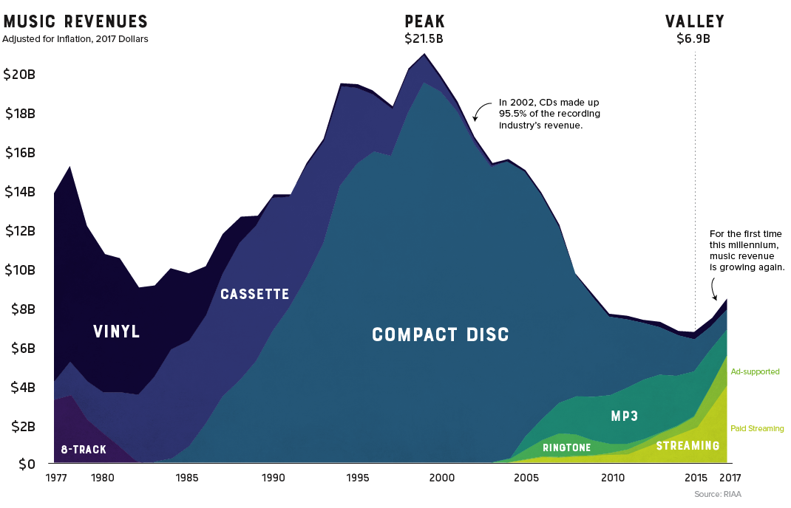

From – “Visualizing 40 Years of Music Industry Sales.” October 6, 2018. By Nick Routley for *Visual Capitalist*. <https://www.visualcapitalist.com/music-industry-sales/>

**Analysis:**

Questions to Ask the Class – What do you like? Dislike? What would you change?